 | 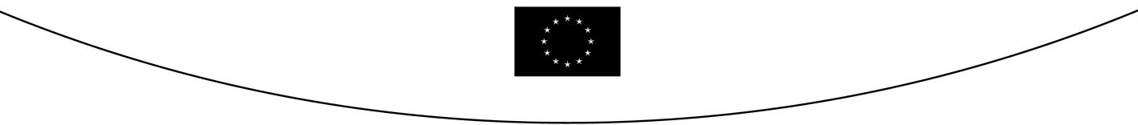
COUNCIL OF  THE EUROPEAN UNION |  |  | Brussels, 12 May 2006
 | Interinstitutional File:  2004/0237 (COD) |  | 9283/06
CODEC 468
DENLEG 27

NOTE
from: | General Secretariat of the Council
to: | COREPER/COUNCIL
No. Cion prop.: | 13489/04 DENLEG 53 CODEC 1119
Subject : | Proposal for a Directive of the European Parliament and of the Council amending Directive 95/2/EC on food additives other than colours and sweeteners and Directive 94/35/EC on sweeteners for use in foodstuffs [First reading]  - Adoption of the legislative act (Public Deliberation) (LA + S)

1. On 14 October 2004 the Commission forwarded the above proposal , based on Article 95 TEC, to the Council.

2. The Economic and Social Committee delivered its Opinion on 6 April 2005 .

3. In accordance with the joint declaration on practical arrangements for the codecision procedure , informal talks were held between the Council, the European Parliament and the Commission with a view to reaching agreement at first reading.

4. The Permanent Representatives Committee examined the outstanding questions and agreed by qualified majority on a compromise text to be sent to the European Parliament in view of an agreement in first reading on 14 October 2005. The results of its deliberations can be found in document 13346/05.

5. The European Parliament delivered its first-reading opinion on 26 October 2005, passing 25 amendments to the Commission proposal. The outcome of voting in the European Parliament reflects the compromise struck between institutions and should thus be acceptable to the Council .

6. The Permanent Representatives Committee is therefore asked to confirm agreement and advise the Council:

- to adopt, as a "B" item on the agenda for a forthcoming meeting, the Directive as contained in PE-CONS 3663/05;

- decide to enter the statements contained in the Addendum to this note in the minutes of that meeting.

Once signed by the President of the European Parliament, the President of the Council and the Secretaries-General of the two institutions, the legislative act will be published in the Official Journal of the European Union.

13489/04
OJ C 255, 14.10.2005, p. 59.
OJ C 148, 28.5.1999, p. 1.
13689/05.

