 | 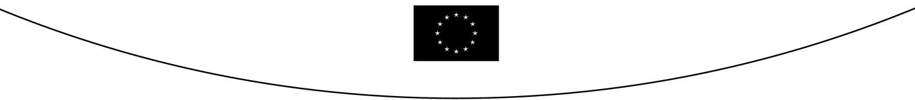
COUNCIL OF  THE EUROPEAN UNION |  |  | Brussels, 28 April 2006
 | Interinstitutional File:  2005/0268 (CNS) |  | 8602/06
CULT 33
COMER 88
COMPET 86
DEVGEN 107
MI 88

REPORT
from : | General Secretariat of the Council
to : | Permanent Representatives Committee (Part 1)
No. Prev. doc.: | 7510/06 CULT 18 COMER 72 COMPET 71 DEVGEN 77 MI 69
No. Cion prop. : | 5067/06 CULT 2 COMER 4 COMPET 1 DEVGEN 2 MI 3-COM(2005) 678 final
Subject : | Proposal for a Council Decision on the conclusion of the UNESCO Convention on the Protection and Promotion of the Diversity of Cultural Expressions  - Adoption

- In November 2004 the Council authorised the Commission to participate, on behalf of the European Community, in negotiations at UNESCO concerning a Convention on the Protection and Promotion of the Diversity of Cultural Expressions. The Commission participated in these negotiations, together with the Member States.

- The Convention on the Protection and Promotion of the Diversity of Cultural Expressions was adopted at the General Conference of UNESCO in Paris on 20 October 2005.

- As a follow-up to these negotiations, the Commission submitted on 21 December 2005 the above proposal.

- The Cultural Affairs Committee considered this proposal on a number of occasions, inter alia, in light of an opinion of the Council Legal Service (6584/06) and achieved full agreement on this draft Decision and its annexes. At the same time, the Committee agreed the herewith appended text of a declaration for the minutes of the Council on the drafting of a code of conduct.

- The European Parliament delivered its opinion - in virtue of Article 300(3) of the Treaty - on 27 April 2006.

- Under these conditions and subject to the agreement of the Permanent Representatives Committee, the Council could be invited:

- to adopt the text of the Decision as it appears in doc. 8668/06;
- to inscribe the appended declaration in its minutes.

____________

Declaration by the Council and the Commission

The Council and the Commission agree that the latter will submit to the Committee of Cultural Affairs a proposal for a Code of conduct between the Council, the Member States and the Commission on certain aspects of the implementation of the UNESCO Convention on the protection and promotion of the diversity of cultural expressions.

______________

Text as revised by the Legal Linguistic experts of the Council Secretariat.

