 | 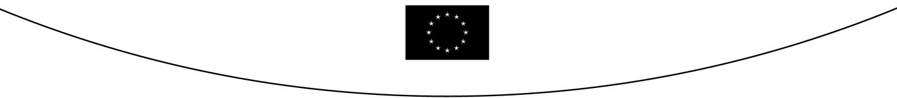
COUNCIL OF  THE EUROPEAN UNION |  |  | Brussels, 12 May 2006
 | Interinstitutional File:  2004/0237 (COD) |  | 9283/06  ADD 1
CODEC 468
DENLEG 27

ADDENDUM TO THE NOTE
from: | General Secretariat of the Council
to: | COREPER/COUNCIL
No. Cion prop.: | 13489/04 DENLEG 53 CODEC 1119
Subject : | Proposal for a Directive of the European Parliament and of the Council amending Directive 95/2/EC on food additives other than colours and sweeteners and Directive 94/35/EC on sweeteners for use in foodstuffs [First reading]  - Adoption of the legislative act (Public Deliberation) (LA + D)  Statements

Statements by the Commission

"In the context of the work on a specific Commission Directive relating to sports foods, including sports drinks, the Commission undertakes to address the question of the use of sweeteners in such products".

"The Commission declares that it will make full use of its competence to adopt emergency measures under Chapter IV, section 2 "Emergencies" of Regulation 178/2002/EC (The Food Law), if the European Food Safety Authority advises that a food additive is not safe for the consumer."

Statement by the Council

" The Council considers that all additive uses of sulphur dioxide and sulphites should be reviewed to ensure that the acceptable daily intake (ADI) is not exceeded. It invites the Commission to take the necessary measures to initiate this examination as soon as possible."

